Test Case: String that is not in language is not accepted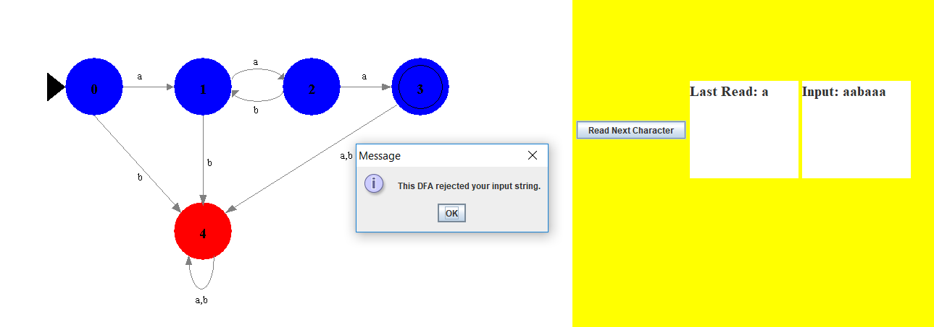

Test Case: String that is in the language is accepted

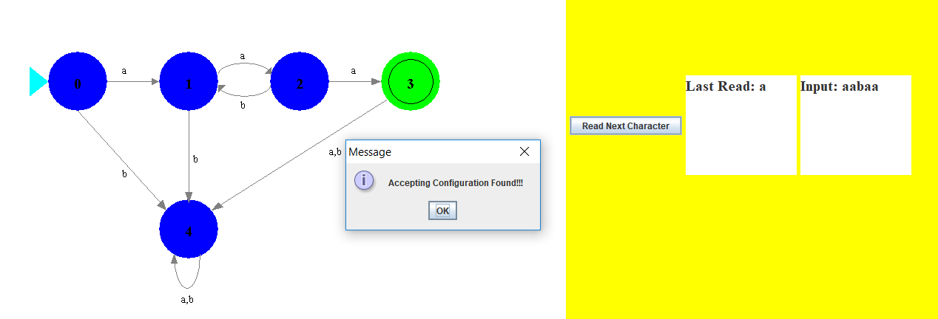 Test Case: Emptystring is read and rejected

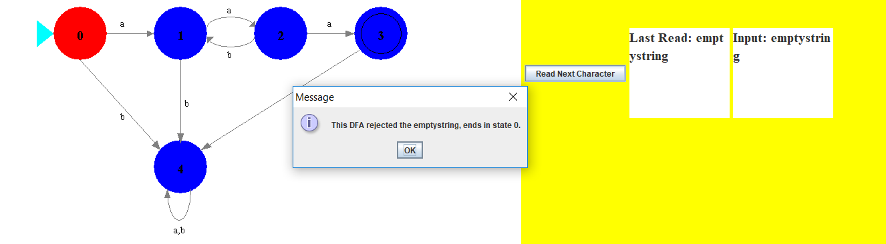

Test Case: Bad input (not a and b strings) is not read into DFA

Before entering:

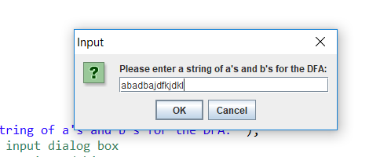

After entering:

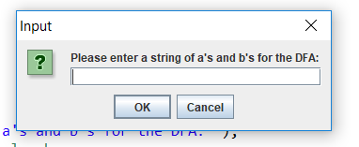

The dialog box pops up again asking for a new string after the invalid string in the first picture is entered.

Test Case: Very long input can be read

